UNIFORM PRE-ORDER REQUEST FORM
SENIOR SCHOOL

Collar:
Measure around base of neck, just below adam’s apple allowing for comfortable fit, about a finger width of room.
Chest:
Measure under arms around the fullest part of the chest.
Waist:
Bend to one side-the natural crease that appears is your waist. Standing straight, measure around your natural waistline.
Sleeves:
With your arms relaxed at your sides and elbows slightly bent, measure from the beginning of your shoulder tip down the outside of arm past elbows to your cuff.
Shoulder to Shoulder:
Measure from the tip of one shoulder, horizontally across the back, to the tip of the other shoulder.
Hips:
Place the measuring tape around the body to the fullest part of the lower hip, feet together.
Inseam:
Without shoes, measure the inside of one leg, from crotch to the floor.
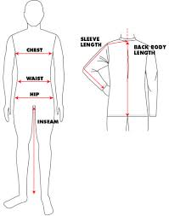

NAME: __________________________________________
CLASS: ________________________
CONTACT NO: ___________________________________

ITEM | Nos  Required | Measurements/  Sizes
Blazer #
Black school trousers
V-neck pullover *
White shirts
School Tie # State House please |  | Alden’s/ Allison’s/ Davis’s/ Dobbin’s/ Price’s/ Yates’s/  School House (Boarder)
CCB Raincoat *
CCB Black PE T-shirt #
CCB Black PE shorts #
CCB Black Rugby Jersey *
CCB Black Rugby shorts *
CCB Tracksuit * |  | Jacket:  Bottoms:
CCB Hoody *  State preference |  | Generic/ Rugby/ Hockey
CCB Games socks |  | Size: Small/ Med/ Large

Basic items (e.g. trousers, shirts) can be purchased from any high street store.
Items marked with an asterix (*) are only available from the College shop.
Items marked with a hash tag (#) are essential and only available from the College shop.

